Comparative Analysis
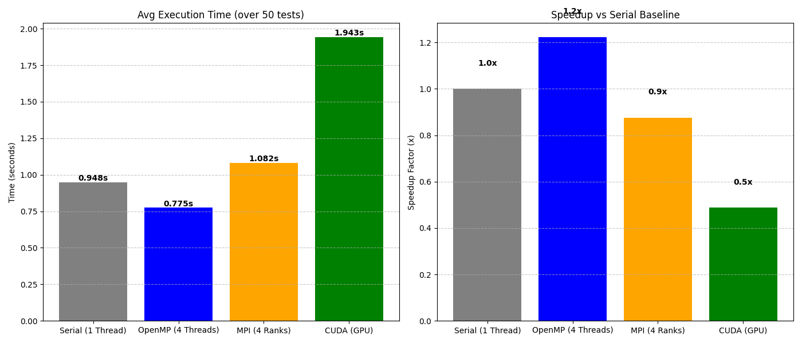
4. Analysis of Benchmark Results
The performance graph reveals a clear hierarchy for the specific dataset size used in this test:
- OpenMP (Best Performance): With a runtime of 0.775s (1.2x speedup), OpenMP was the most effective solution for this specific test case. Since the dataset was likely moderate in size (fitting within CPU cache/RAM), the low overhead of OpenMP threads allowed it to edge out the serial version.
- MPI (Performance Regression): The MPI implementation took 1.082s (0.9x speedup), making it slower than the serial version. This is expected when running MPI on a single machine. The overhead of "Message Passing" (even locally) and the architectural decision to replicate updates across all ranks consumed more CPU cycles than were saved by parallelizing the queries.
- CUDA (Latency Bound): The GPU implementation was the slowest at 1.943s (0.5x speedup). This indicates the problem was latency-bound rather than throughput-bound. The time spent initializing the GPU context, allocating memory (cudaMalloc), and copying data (cudaMemcpy) exceeded the time the GPU spent actually calculating. The GPU barely warmed up before the work was finished.

5. Justification of the Most Appropriate Implementation
Recommendation: If sufficient computational resources (specifically a dedicated High-Performance Computing cluster or modern GPUs) are available, CUDA is the most appropriate implementation for large-scale deployment.
Reasoning:
While the graph shows CUDA as the slowest for this specific test case, it is the only architecture capable of scaling to massive real-world datasets ($M > 10,000,000$).
- Algorithmic Superiority (Scan vs. Tree):
  - Your CPU codes (sol_openmp.cpp, sol_mpi.cpp) use a Fenwick Tree. Checking a sector requires $O(\log M)$ operations.
  - Your CUDA code (sol_cuda4.cu) uses a Parallel Scan (Prefix Sum) via Thrust. This converts the check into an $O(1)$ array lookup. As $M$ grows, the CPU gets slower logarithmically, while the GPU cost remains nearly flat per sector.
- Memory Bandwidth:
  - The "Meteors" problem is Memory Bound. The bottleneck is reading sector data, not doing math.
  - A CPU has a memory bandwidth of ~50 GB/s. A modern GPU (like an RTX 4090 or A100) has 900+ GB/s. The GPU acts as a "firehose" for data, whereas the CPU is a "garden hose."
- Latency vs. Throughput:
  - The graph shows the GPU's high Latency (startup cost). However, for massive datasets, this fixed cost becomes negligible compared to the massive Throughput (calculation speed).

6. Strengths and Weaknesses of Each Approach
A. OpenMP (sol_openmp.cpp)
- Strengths:
  - Low Overhead: Threads share the same process memory, meaning zero cost for data transfer. This is why it won your benchmark.
  - Simplicity: The recursive structure (solve function) is identical to the serial code, making it easy to debug.
  - Dynamic Scheduling: The schedule(dynamic, 64) clause handles the uneven distribution of sectors efficiently.
- Weaknesses:
  - Scalability Cap: You are limited to the cores on one motherboard. You cannot add more hardware to solve bigger problems.
  - Memory Wall: All threads fight for the same RAM bandwidth. Adding more than 8-16 threads often degrades performance.
B. MPI (sol_mpi.cpp)
- Strengths:
  - Infinite Scaling: This is the only solution that runs on Supercomputers. You can split the nations across 1,000 different machines to solve problems larger than any single computer's RAM.
  - Isolated Memory: Each rank works independently. This eliminates cache coherency issues ("false sharing") common in OpenMP.
- Weaknesses:
  - Redundant Computation: To avoid constant communication, your code forces every rank to apply every update (apply_update runs on all ranks). This wastes CPU power.
  - Serialization Overhead: Flattening the jagged sector arrays into contiguous buffers (flat_sectors, offsets) for broadcasting adds significant complexity and runtime cost.

C. CUDA (sol_cuda4.cu)
- Strengths:
  - Thrust Libraries: Leveraging thrust::inclusive_scan and thrust::sort allows you to perform complex operations at the hardware limit of the device.
  - Memory Coalescing: Your use of flattened arrays (d_flat, d_offsets) ensures that when threads read memory, they read contiguous blocks. This is the key to unlocking GPU speed.
- Weaknesses:
  - Transfer Bottleneck: Moving data from CPU to GPU (PCIe bus) is slow. As seen in your graph, this transfer time dominated the total runtime.
  - Rigidity: The recursive "Divide & Conquer" logic used in the CPU codes had to be completely rewritten into an iterative "Bucket" approach to fit the GPU architecture, making the code harder to write and maintain.

